(COVER (mandatory item – NBR14724, item 4.1.1))

Vinicius Kenji Kumagai

[PENDENTE: título do trabalho] : [PENDENTE: subtítulo, se houver]

SÃO PAULO
2026

(COVER PAGE (mandatory item – NBR14724, item 4.2.1.1))

Vinicius Kenji Kumagai

[PENDENTE: título do trabalho] : [PENDENTE: subtítulo, se houver]

Final Course Project submitted to the Institute of Technology and Leadership (INTELI), to obtain a bachelor's degree in [PENDENTE: curso].
Advisor: Prof. Pedro Teberga
Coadvisor (if applicable): [leave blank]

SÃO PAULO
2026

(Catalog Card (mandatory item – NBR14724, item 4.2.1.1.2))

Cataloging in Publication
Library and Documentation Service
Institute of Technology and Leadership (INTELLI)
Data entered by the author.
(Cataloging record with international cataloging data, according to NBR 14724. The record will be completed later, after approval and before the final version is deposited. The completion of the cataloging record is the responsibility of the institution's library.)

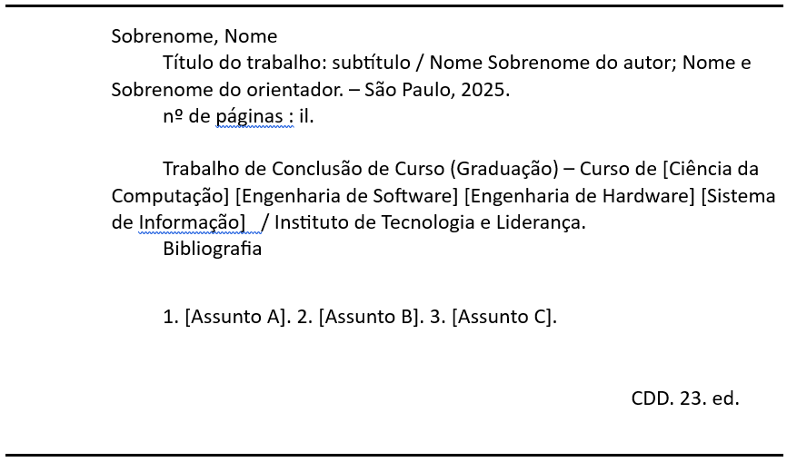

Acknowledgments (optional item) – NBR14724, item 4.2.1.5)
[PENDENTE: agradecimentos]

Epigraph (optional item – NBR14724, items 4.2.1.6 and 5.2.4)
[PENDENTE: epígrafe]
Resumo (mandatory item – NBR 14724, item 4.2.1.7)

KUMAGAI, Vinicius Kenji. [PENDENTE: título do trabalho]. 2026. [PENDENTE: número de folhas]. TCC (Graduação) – Curso [PENDENTE: curso], Instituto de Tecnologia e Liderança, São Paulo, 2026.

[PENDENTE: resumo]
Palavras-Chave: [PENDENTE: palavra-chave 1]; [PENDENTE: palavra-chave 2]; [PENDENTE: palavra-chave 3].

ABSTRACT (mandatory item – NBR 14724, item 4.2.1.8)

KUMAGAI, Vinicius Kenji. [PENDENTE: title of the work]. 2026. [PENDENTE: number of pages]. Final Course Project (Bachelor) – Course [PENDENTE: course], Institute of Technology and Leadership, São Paulo, 2026.

[PENDENTE: abstract]

Keywords: [PENDING: keyword 1]; [PENDING: keyword 2]; [PENDING: keyword 3].

List of Illustrations (optional item – NBR14724, item 4.2.1.9)

Figure 1 – [Figure 1 Title]................................................................................page] Figure 2 – [Figure 2 Title]................................................................................page] Figure 3 – [Figure 3 Title]................................................................................page] Figure 4 – [Figure 4 Title]................................................................................page]

List of Tables (optional item – NBR14724, item 4.2.1.10)

Table 1 – [Table 1 Title]...............................................................................page]
Table 2 – [Table 2 Title]...............................................................................page]
Table 3 – [Table 3 Title]...............................................................................page]
Table 4 – [Table 4 Title]...............................................................................page]

List of Abbreviations and Acronyms (optional item – NBR14724, item 4.2.1.11)

ACRONYM 1 Full name of acronym 1
ACRONYM 2 Full name of acronym 2
ACRONYM 3 Full name of acronym 3

Summary (mandatory item – NBR14724, item 4.2.1.13; NBR 6027)

1 Introduction 10
2 [Solution Development] 11
2.1 [Definition of Market Premises and Hypotheses:] 11
2.2 [Market Sizing and Analysis:] 11
2.3 [Competitive Analysis and Differentiators:] 12
2.4 [Technological Solution] 12
2.5 [The Business Plan] 13
2.6 [Validation and Results] 15
3 Conclusion 16
References 16
Appendices 17
Annexes 17

Introduction (For titles and numerical indicators, see NBR 14724, item 5.2.2; for progressive numbering, see NBR 6024)

[PENDENTE: redigir introdução com contexto, problema, proposta de valor, objetivos e justificativa.]

  - Context and Motivation:
  - Presentation of the area of expertise and the problem that the solution aims to solve;
  - What market opportunity has been identified?

  - Problem Definition and Value Proposition:
  - Detailed description of the problem (customer pain point).
  - Presentation of the Value Proposition (How the solution will alleviate the pain/generate gain).

  - Objectives of the Work:
  - General: Create/Validate a computational solution and develop a business plan for its introduction to the market;
  - Specifics: (e.g: Develop MVP X, Perform validation with Y customers, Define revenue model Z, etc.).

  - Justification and Contributions:
  - Market, technological, and economic relevance of the solution.

  - Work Structure:
  - Brief description of the content of each subsequent chapter.]

[Solution Development]

[Definition of Market Assumptions and Hypotheses:]

[PENDENTE: detalhar hipóteses de problema, solução e valor.]

    - Problem Hypothesis
What is the assumption about the customer's pain point? ( Example : "Public X faces problem Y, and they are willing to pay to solve it.")

    - Solution Hypothesis
What is the assumption that the proposed computational solution is the best way to solve the problem?

    - Value Hypothesis
What is the assumption that the price and revenue model are acceptable to the customer?

[Market Sizing and Analysis:]

[PENDENTE: preencher TAM, SAM, SOM e perfil de cliente.]

    - Market Size (TAM, SAM, SOM):
    - Calculation or estimation of TAM (Total Addressable Market);
    - Calculation or estimation of SAM (Serviceable) Available Market (Market Available for Services)
    - Calculation or estimation of SOM (Serviceable Obtainable Market - The achievable market share, or the segment that can be initially captured.

    - Customer Segmentation and Profiling
Detailed Description of the Persona and Target Customer Segment]

[Competitive Analysis and Differentials:]

[PENDENTE: preencher análise competitiva e diferenciais.]
  - Identification of Direct and Indirect Competitors ;
  - Analysis of competitors (prices, features, strengths/weaknesses);
  - Definition of the Competitive Advantage and Differentiating Factor of the proposed solution.

[Technological Solution]

[PENDENTE: descrever requisitos, arquitetura, implementação do MVP e avaliação técnica.]

    - Requirements and Specifications:

  - Functional and Non-Functional Requirements of the system;
  - User Specifications and Use Cases.

    - Architecture and Technology:

  - System Architecture ( e.g. , Client-Server, Microservices, Cloud ).

    - Development and Implementation (MVP):

  - Description of the development methodology (Scrum , Kanban , etc.);
  - Development phases, modules, and features implemented in the Minimum Viable Product (MVP) .

    - Testing and Technical Evaluation:

  - Testing strategies ( Unit, Integration, Acceptance );
  - Results from tests demonstrating the functionality and technical robustness of the product.

[The Business Plan]

[PENDENTE: preencher plano de negócios.]

    - Market and Competitor Analysis:

  - Segmentation and Target Audience (Persona).
  - Analysis of Strengths, Weaknesses, Opportunities, and Threats (SWOT Analysis) .
  - Analysis of competitors and product differentials .

    - Business Model (Business Model Canvas - BMC):

  - Presentation and details of each block of the BMC.

    - Marketing and Sales Strategy:

  - Go -to -Market Strategy (How the product will be launched).
  - Customer acquisition and retention strategies.

    - Financial Projection and Feasibility:

  - Revenue Model and Pricing Structure.
  - Projected expenses, break - even point , and viability indicators (e.g. ROI).
  - Definition of the initial investment requirement .

[Validation and Results]
[PENDENTE: preencher validação e resultados.]

    - Validation Methodology:

  - Description of the method used to test the business hypothesis and the acceptance of the MVP ( e.g. , customer interviews, A/B testing, landing page with lead generation ).

    - Market Validation Results:

  - Presentation of collected data ( Customer feedback , Engagement metrics , Conversion rate, etc.).
  - Pivoting or Persisting: Discussion about the changes (if any) made to the Business Model or Product based on real feedback .

    - Key Performance Indicators (KPIs):

  - Presentation of key performance metrics (e.g. , CAC - Customer Acquisition Cost, LTV - Lifetime Value) . Value , Churn Rate ).

    - Risks and Mitigation Plan:
  - Identification of critical business risks (financial, technological, legal, competitive) and actions to mitigate them.

Conclusion

[PENDENTE: concluir trabalho, limitações e próximos passos.]

References (mandatory item – NBR14724, item 4.2.3.1; NBR 6023)

(# References must comply with the rules of NBR6023 (Preparation of References;
Only the works consulted and cited in the text should be included in the list of references.
# font size 12
# prepared using single spacing;
# aligned to the left margin of the text and without indentation;
# separated from each other by a single blank line;
For online documents, the web address must be indicated, preceded by the expression "Available at:" and the access date preceded by the expression "Accessed on:";
The author should be indicated by their last name, in capital letters, followed by their first name and other last names, abbreviated or not; authors should be separated by semicolons.
When there are up to three authors, all must be listed;
When there are four or more authors, you can list all of them, or only the first one followed by the expression et al .

(# Examples:

Book:

[LAST NAME, First Name. Book Title : Subtitle. Edition. Publisher Location: Publisher, Publication Date.]

[PRESSMAN, RS; MAXIM, BR Software Engineering : A Practitioner's Approach. 9th ed. Porto Alegre: AMGH, 2021.]

[BASS, L.; CLEMENTS, P.; KAZMAN, R.; Software architecture in practice . 4th ed. Boston: Addison-Wesley, 2022.]

Article:

[LAST NAME, First Name. Article Title: Subtitle. Journal Name , Publication Location, Volume, Number, Pages, Publication Date. Available at: [electronic address]. Accessed on: [date of last access]]

[SANTOS, EH; BENITES, CS; STATERI, J. Study of artificial intelligence within the scope of PBL teaching. Contemporary Journal . [ S. l. ], v. 4, n. 9, p. 01-18, 2024. Available at: https://ojs.revistacontemporanea.com/ojs/index.php/home/article/view/5781/4271 . Accessed on: Oct. 27, 2025.

[VALENTE, JA; BITTENCOURT, II; SANTORO, FM; GARCIA, M.; ISOTANI, S.; GARCIA, A.; HABIMORAD, M. Project-Based Higher Education in Computing: Inteli on the path to innovation. Brazilian Journal of Informatics in Education , [ S. l. ], v. 33, p. 605–642, 2025. Available at: https://journals-sol.sbc.org.br/index.php/rbie/article/view/4320. Accessed on: Oct. 27, 2025.]

[VALENTE, JA et al . Project-Based Higher Education in Computing: Inteli on the path to innovation. Brazilian Journal of Informatics in Education , [ S. l. ], v. 33, p. 605–642, 2025. Available at: https://journals-sol.sbc.org.br/index.php/rbie/article/view/4320. Accessed on: Oct. 27, 2025.]

)

Appendices (optional item – NBR14724, item 4.2.3.3) (For titles without numerical indicators, see NBR 14724, item 5.2.3)

[Supporting document: text or document prepared by the author, used to support their argument and aid in understanding the main text without compromising the content presented in the body of the work. Ex : tables, reports, questionnaires, programming code, etc.]

Annexes (optional item – NBR14724, item 4.2.3.4)

[Supporting document: text or document not created by the author, but which serves as a basis, proof, or illustration of the content of the work. Ex : tables, reports, laws, manuals, etc.]

